Council
Minutes

SCPT Council Meeting Minutes via Teleconference on March 22, 2021 via Redbooth 7:00-8:24 pm
Present through Zoom: B. Green (EDR); D. Shuya; C. Cuddington; D. Pitura; L. McLellan; J. Hunchak; J. Grant; A. Crow; K. Horvey; K. Mueller; D.Poncsak; K. Harrison; K. Large
Absent: None.
Agenda (general discussion points) provided by D. Shuya.
Meeting start 7:01 pm
EDR reviews that all communication in emails regarding the PCE clinical exam are confidential. Reviewed importance for discussion that everyone participates.
H. Burridge joins meeting at 7:06 pm.
D. Shuya introduces Heather Burridge, committee chair for the Registration committee and previous Council member.
In camera session starts 7:11 pm.
H. Burridge leaves meeting at 8:10 pm.
In camera session ends 8:23 pm.
Meeting adjourned 8:24 pm.

President ___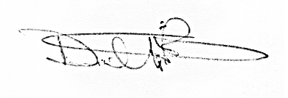__________ Date _____June 6,2021________________

Secretary _______________________________________Date _____June 3, 2021______________

