Council
Minutes

SCPT Council Meeting Minutes via Teleconference on March 31, 2021 via Redbooth 7:00-8:22 pm
Present through Zoom: B. Green (EDR); D. Pitura; C. Cuddington; L. McLellan; J. Hunchak; J. Grant; A. Crow; K. Horvey; D.Poncsak; K. Harrison; K. Large; M. Rasmussen (SCPT lawyer)
Absent: D. Shuya; K. Mueller.
Agenda (general discussion points) provided by B. Green.
Meeting start 7:01 pm by D. Pitura
Item for Decision
Pelvic Health Course discussed (information provided to Council before meeting)
Motion: to approve the “Women’s Health Training Associates- Women’s Health Physiotherapy 5 Day Intensive Course” for pelvic health.
Mover: L. McLellan
Seconder: A. Crow
CARRIED: MOTION 21.014
Motion: to move to In Camera discussion.
Mover: D. Poncsak
Seconder: L. McLellan
CARRIED: MOTION 21.015
In Camera starts 7:06 pm.
In Camera ends 8:22 pm.
ACTION: EDR to draft an eblast for Council to review before being sent to membership.
ACTION: Legislation committee to attempt to create some bylaw options relating to Covid and future extenuating circumstances.
Meeting adjourned at 8:22 pm.

President ___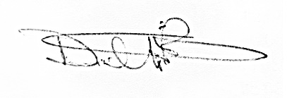___________ Date _____June 6,2021________________

Secretary _______________________________________Date _____June 3, 2021_______________

